**30 User Interface Layouts Used in UI Design**



Roshni Shaikh

June 12, 2023

UX

10,500 websites are created every [hour](https://300mind.studio/blog/ui-ux-design-statistics/).

75% of the time, a website’s credibility is judged based on a website’s overall aesthetics, says a [BCS report](https://www.bcs.org/).

When you land on a website, the visitor should be able to easily figure out the information they need without getting confused or frustrated. That's a good user experience with an intuitive user interface.

However, the reality is that most websites don’t give the user a good experience. The buttons are misplaced. The text overlaps large images making it hard for the reader to read. Branding overflows the design and the text is illegible – which makes it hard for the reader to understand and connect with the message.

# What is a user interface layout?

A good UI layout arranges how different components such as buttons, menus, text fields, images, and other interactive elements in an organized fashion for the user on a digital platform, such as a website, mobile app, or software application.

User interface design is an ever-evolving domain. And as tech and design trends progress, new layout types keep emerging to engage and meet the expectations of the evolving user.

Here are 30+ user interface layout types for dynamic design:

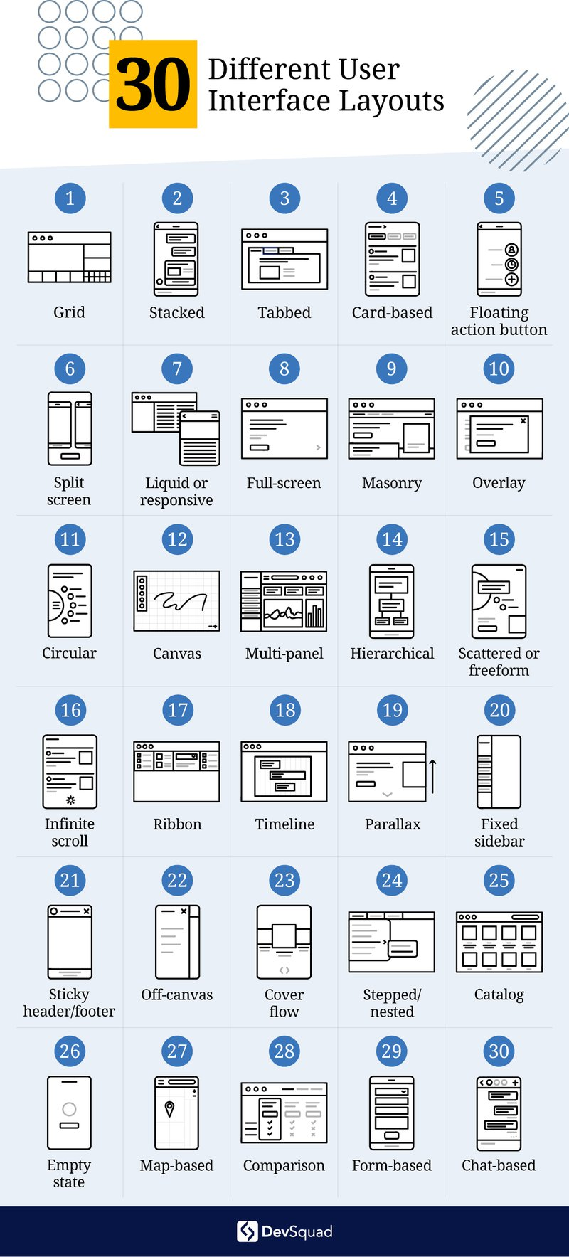

# 1. Grid layout

Most ecommerce sites use the grid layout on their websites. Organizing UI elements within rows and columns to display multiple items of the same size on a page is called a grid layout. A grid layout structure is chosen to give consistency and visual harmony to the page with a large amount of data.

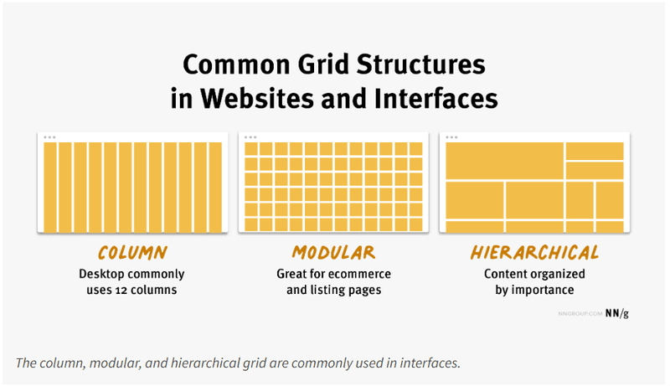An example of grid [layouts](https://www.nngroup.com/articles/using-grids-in-interface-designs/)

# 2. Stacked layout

Stacked layouts, also known as vertical or linear layouts, arrange elements vertically or horizontally. This layout is commonly used for displaying lists or content that needs to be presented in a sequence, such as a chat conversation or a news feed.

Each element occupies the full width or height of the screen, and new elements are added below or beside the existing ones. Stacked layouts are commonly used in lists, feeds, and step-by-step processes.

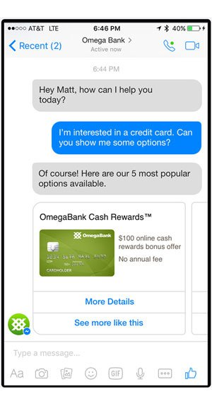

[An example showing a stacked UI layout](https://emplifi.io/resources/blog/examples-of-facebook-messenger-chatbots)

# 3. Tabbed layout

Tabbed layout divides the screen into multiple tabs where each tab represents a different section or category of content. Users can switch between tabs to access different sets of information or functionality. Tabbed layouts are often used when there is a need to present a large amount of classified content in a compact space.

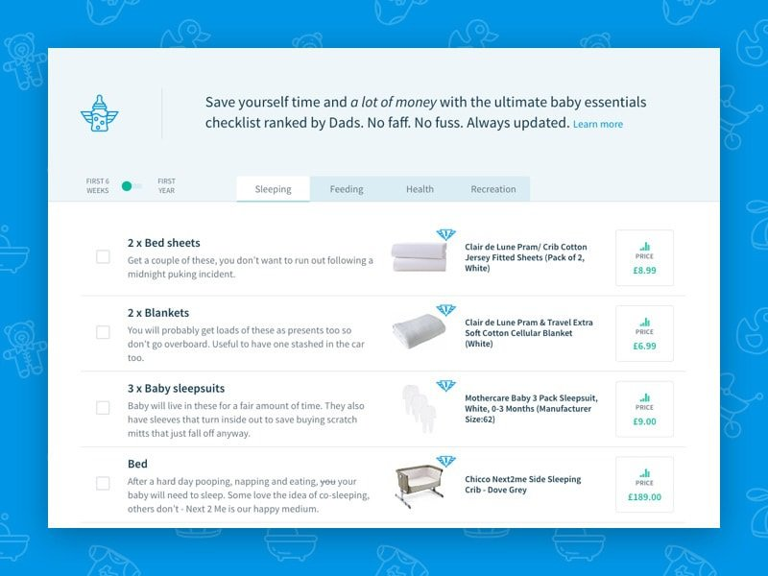Snapshot of an e-commerce website with [tabbed UI layouts](https://designmodo.com/tabbed-widgets/)

# 4. Card-based layout

Card-based layouts use individual cards or tiles to display discrete units of content or functional services. Each card contains an image, a title, and additional information or actions. Card-based layouts are popular in social media feeds, e-commerce product listings, and content aggregator sites such as Google News or Apple News. This layout is used in sites where a visually appealing modular representation is required.

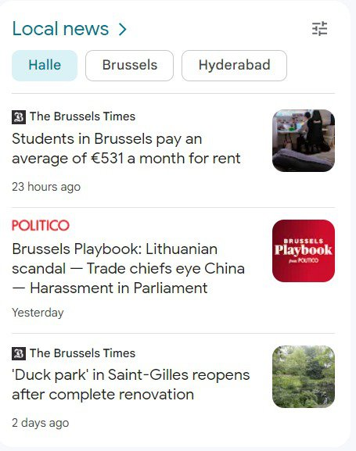

An example of a card-based UI layout

# 5. Floating action button layout

This type of layout comes with a distinguished button that represents the most frequently used action in a website/application. The button is positioned at a fixed location on the screen and is used to trigger key interactions between the system and the user. Other UI elements are placed around the floating button, creating a visually centered layout.

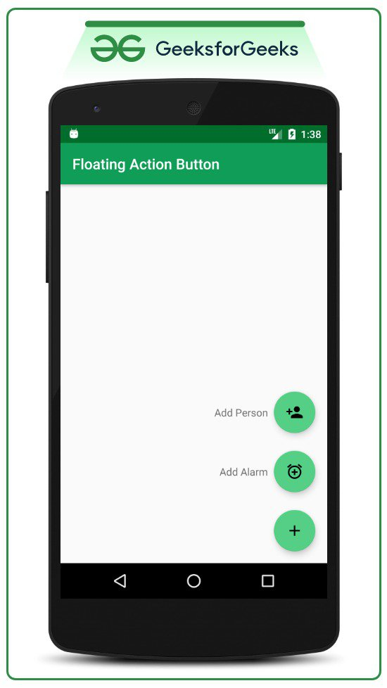

An example showing [floating action buttons layout](https://images.app.goo.gl/WoVFbCyC9G4NNHgC8)

# 6. Split screen layout

Split screen or split-view layouts divide the interface into two or more sections, horizontally or vertically to allow users to view and interact with two sets of information on multiple screen components simultaneously.

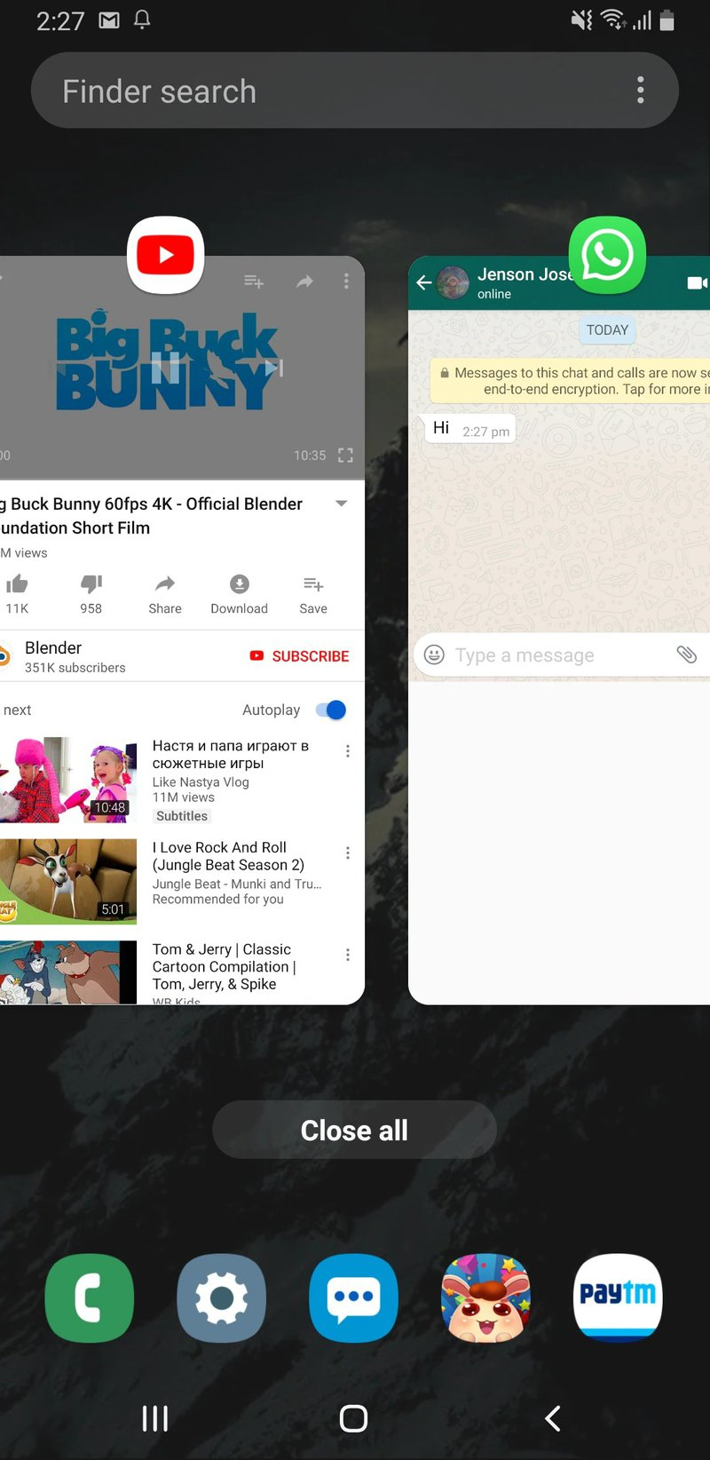

A snapshot showing a [split-screen layout](https://images.app.goo.gl/3ajvmErGe8GdHPneA)

# 7. Liquid layout or responsive layout

Also known as fluid layout, a liquid layout adapts to the interactivity of the UI elements based on the device, screen size, or resolution.

This layout ensures that the interface uses the screen space effectively, regardless of the device or screen size. Liquid layouts are commonly used in responsive web design. Responsive layouts are designed to provide an optimal user experience across various devices, screen sizes, or resolutions. They also provide a more tailored experience for the users. However, it requires building and maintaining separate layouts for each target and it’s expensive.

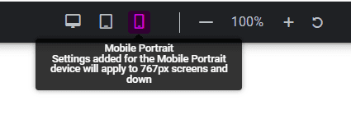

Elementor.com has the option to build a web page with a fluid layout that suits various digital devices such as mobile, tablet, or a PC.UI

# 8. Full-screen layout

Full-screen layouts use the entire screen space to display content or functional services. The purpose here is to get rid of distractions and bring the user's attention to the intended call to action or message. Full-screen layouts are commonly used in multimedia presentations, immersive experiences, storytelling websites, portfolios, landing pages, and specific mobile applications. Each section often covers the entire viewport, offering a seamless and immersive browsing experience.

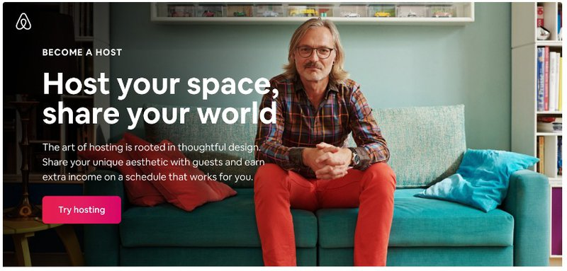An example of a full-screen UI layout

# 9. Masonry layout

Masonry layouts position interactive elements in asymmetric columns or rows. It’s a grid-like structure, but unlike traditional grid layouts, the elements have varying heights or widths.

This layout style allows for more flexibility in accommodating content of different sizes, such as images or text blocks. Masonry layouts are often used in [portfolio](https://images.app.goo.gl/Kr4DgAdRnSjexTqR6)websites or image galleries.

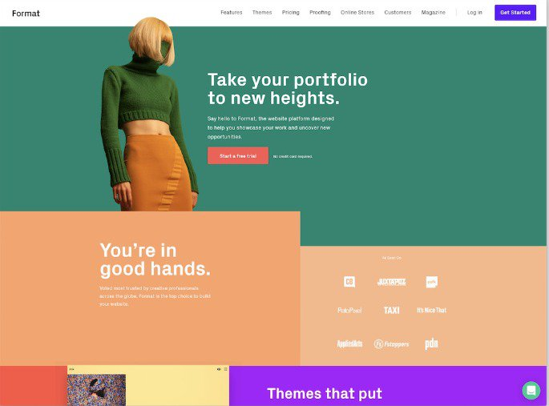An example of a[masonry layout](https://images.app.goo.gl/Kr4DgAdRnSjexTqR6)

# 10. Overlay layout

Some pages display additional content or interactive elements overlapping on top of the existing interface to display notifications, modal dialogs, pop-up windows, etc. Overlay layouts are designed to keep the main interface fully functional while the user accesses the notifications or [pop-ups](https://images.app.goo.gl/rizSCkwNdXKHBKSN7).

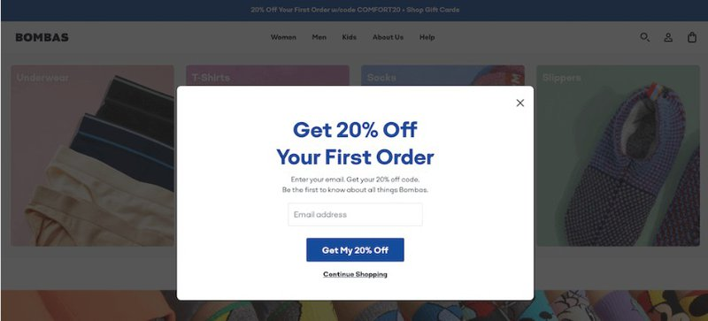A pop-up overlaying on a web page is a classic example of an [overlay UI layout](https://images.app.goo.gl/rizSCkwNdXKHBKSN7)

# 11. Circular layout

When you’re shopping for a SaaS product, you usually see a section where the product seamlessly integrates with external apps. This representation is generally done in a circular layout fashion where the elements are positioned along a circular path or in a radial arrangement.

This layout type is visually distinctive and can be useful for representing hierarchical or non-hierarchical relationships. Circular layouts are often seen in data visualizations, menu systems, and control interfaces.

An example of a [circular UI layout](https://images.app.goo.gl/9LaS34YkmbybxccH9)

# 12. Canvas layout

Canvas layouts offer a blank canvas or an open workspace where users can use the tools to create freely. This layout type is commonly used in whiteboard tools like Miro, graphic design tools like Canva, and drawing applications like Paint, etc are good examples of a canvas layout.

# 13. Multi-panel layout

Multi-panel layouts divide the interface into multiple panels or panes, each displaying different sets of content or functionality. Users can interact with and switch between panels to navigate the content and access the discrete functions specific to each panel. Multi-panel layouts are often used in complex applications like IDEs (Integrated Development Environments) or dashboard systems to present summarised information, statistics, or analytics in a visually appealing and concise form. Dashboard layouts are frequently used in data visualization, business intelligence tools, and admin panels.

# 14. Hierarchical layout

Hierarchical layouts organize UI elements in a hierarchical or tree-like fashion to represent the relationship between two elements or components.

# 15. Scattered or freeform layout

Scattered or freeform layouts allow for the non-linear placement of UI elements. This type of layout is often used in creative applications or interfaces that require a flexible, more malleable, and non-conventional arrangement of content.

# 16. Infinite scroll layout

Social media apps like Facebook, LinkedIn, and Twitter are built to make you doom scroll. This kind of user interface layout is called infinite scroll. This is used to display unlimited content on your social media feed.

# 17. Ribbon layout

Ribbon layouts display fixed or flexible, horizontal or vertical strips of content information. Ribbon layouts are commonly used in productivity tools like Trello, Asana, ClickUp, etc. Word processors like Google Docs is also a good example of a ribbon layout.

Ribbons help the user find the various commands and functions needed to perform a task quickly and efficiently. A ribbon layout is the strategic structuring of product features and functionality.

Microsoft says that using a ribbon layout in software tools helps the user feel more in control of their [experience](https://learn.microsoft.com/en-us/windows/win32/uxguide/cmd-ribbons)with the program.

# 18. Timeline layout

Timeline layouts arrange content in chronological order along a horizontal or vertical axis. This layout is ideal for displaying events, activities, or storytelling. Timeline layouts are commonly used in history apps, project management tools, or social media platforms to display posts, events, or updates based on the time of the event.

# 19. Parallax layout

Parallax layouts create an illusion of depth by spacing and shifting different layers of UI elements at different speeds producing an effect. For example, if a user scrolls or interacts with the interface, the color of the interface changes. Web app/site design with a parallax layout adds a dynamic and dramatic visual effect making it a memorable experience for the user.

# 20. Fixed sidebar layout

Fixed sidebar layouts are designed to place attention on a persistent sidebar that remains fixed in position while the other content on the page or application is free for scrolling. In general, the sidebar contains navigation menus, filters, or secondary actions, providing quick access to the most frequently used features.

Most blogs have fixed social media buttons to the left, right, or center of the page. These buttons are usually fixed while you scroll through the blog.

# 21. Sticky header/footer layout

Sticky header/footer layouts keep the header or footer section of the interface fixed at the top or at the bottom of the screen as the user scrolls. This ensures that the fundamental navigation or information remains prominently visible and accessible at all times.

Most research websites have the sticky header or footer layout employed to display crucial information at all times.

# 22. Off-canvas layout

Off-canvas layouts hide secondary or non-essential content from the main screen. However, the content can be revealed by performing a specific action, such as clicking a navigation menu bar or a [doner menu](https://devsquad.com/blog/user-interface-design). This layout is useful as it saves space and looks clutter-free.

# 23. Cover flow layout

If there’s one way to catch the attention of a rushing web visitor, designers use the cover flow layout. Cover flow layouts display content or items in a visually attractive fashion just like a web carousel.

Cover flow layouts were first designed by Macintosh engineers to help users explore files and folders by visually flipping through snapshots of the folder content.

# 24. Stepped layout/nested layout

The stepped layout navigation experience or the nested layout, also called wizard or stepper layouts is designed to steer the users through a series of dependent steps of instructions or information. Each step typically focuses on a specific task and helps the visitor complete the task.

To understand this better, let’s take Google Sheets as an example.

In order to have an even row and box size irrespective of the size of the information, you need to select the “Wrap” function in Google Sheets.

However, to arrive at this function, you need to navigate three steps down namely:

**Step 1:** Click on ‘Format’

**Step 2:**Click on ‘Wrapping’

**Step 3:**Select ‘Wrap’

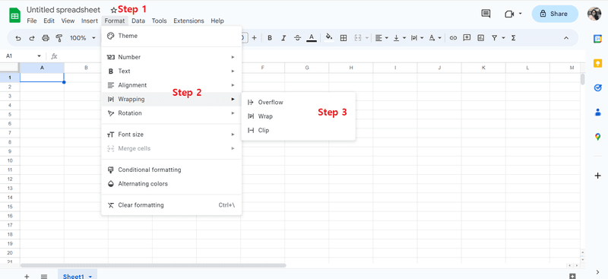Stepped or nested UI layout

# 25. Catalog layout

When you shop on [Amazon](http://amazon.com/)for a shower cap, a catalog of showering products shows up on your search screen. A catalog design layout is the structuring of products or services exactly like a traditional paint catalog book. The products are displayed with a thumbnail image, a short description, and pricing information.

Catalog layouts are predominantly used in e-commerce and online marketplaces.

# 26. Empty state layout

An empty state is the first encounter/interaction between a virtual location and the user. Empty state layouts are displayed when there is no data to be shown.

For example, when you navigate a new and empty Google Drive folder, it shows an empty state layout to indicate there’s nothing in the folders.

These layouts often serve as starting points for users and provide helpful messages, prompts, or suggested actions to encourage users to explore the product further.

# 27. Map-based layout

When you visit the website of a restaurant or a public commune, they generally have a map to check the distance to the destination from your current location. That’s a map-based layout. Map-based layouts come with interactive maps as the central function of the interface. They can display locations, routes, or geospatial data, allowing users to interact with the map and access additional information or features.

Map-based layouts are widely used in navigation apps, travel websites, and location-based services. Facebook marketplace is one of the finest examples to understand map-based layouts.

# 28. Comparison layout

Buying insurance is a major decision. And when you’re insurance shopping on the internet, you’re obviously looking for the best deal in terms of value, genuinity, and returns. When you have a couple of options in hand, your first instinct is to compare the options with one another. Doing this manually can be tedious and time-consuming. That’s why insurance websites like policybazaar.com offer comparison layout interfaces to make it easy for the user to compare the features of a product before making a purchase decision.

Comparison layouts allow users to compare two or more items side by side, highlighting their similarities, differences, advantages, and disadvantages. This layout is often used in product comparison tables, feature comparison charts, or pricing plans.

# 29. Form-based layout

Usually, a landing page targeting high-intent buyers that a user clicks from a Google ad can take them to a page with a form-based layout. A form-based layout may consist of [UI design elements](https://devsquad.com/blog/user-interface-design#dgie8) such as input fields, checkboxes, radio buttons, and dropdown menus. They aim to simplify data entry, validation, and submission processes. Form-based layouts are commonly used in registration forms, contact forms, or data entry interfaces.

# 30. Chat-based layout

Chat-based layouts are employed to build messaging interfaces or conversation rooms. They typically feature message bubbles, user avatars, timestamps, input fields to compose messages, attachments for file sharing and exchange, theme settings, etc. Chat-based layouts are widely used in messaging apps like Facebook Messenger, customer support platforms like [Hubspot](https://developers.hubspot.com/docs/api/conversation/chat-widget-sdk), collaborative tools like Slack, and peer-to-peer messaging applications like WhatsApp.

# Key takeaways

Designers often create custom layouts or club multiple patterns to meet the target needs and aesthetics of an application or a website. The decision to choose a UI layout depends on several factors such as the type of content being presented, the target audience, the big idea of the digital project, and the overall design goals.

Therefore, a well-designed UI layout takes into consideration factors such as:

* [Usability](https://devsquad.com/blog/ux-design-principles)
* [User experience](https://devsquad.com/blog/user-experience-design-process)
* Information hierarchy
* Speed
* Aesthetic appeal
* Branding guidelines
* Target platform
* Nature of the application
* Overall design objectives

UI layouts are chosen by designers to meet the functional and aesthetic requirements of the tool to give the target users a seamless service or experience.

To build unique digital products, you need experienced design strategists, product managers, UX designers, and engineers. DevSquad has assembled a proficient product management/development team that’s built products for brands like [ADP](https://www.adp.com/), [Box](https://www.box.com/en-gb/home), [Swell,](https://www.swellcx.com/)etc. DevSquad is where product strategy meets execution.